Why wear hard hats?
The brain is the control center of the body. If it is damaged in any way, the entire body will be at risk. Normally the skull protects the brain from injury, but when falling or flying objects are a hazard, additional protection must be worn.
Sometimes workers are reluctant to wear hard hats:
The hat’s weight and heat are cited as being uncomfortable. However, not only will the hats protect your head from injury, they may be more comfortable than you think.

A hard hat’s weight:
- A hat’s weight is part of its safety.
- The average hat weighs about 14 ounces.
- The average human head weighs 13 - 14 pounds.
- Therefore, a hat contains an ounce of safety for each pound of head, provided that the head protection is properly worn and maintained.
- The hat’s weight is comparatively small.
- The helmet used in World War II and the Korean conflict was three pounds. In the duress of battle, the soldiers’ helmets afforded a psychological feeling of security. Hopefully the hard hat will also provide feelings of security.

A hard hat’s temperature:
- Researchers found that the inside temperature of a hat was approximately 5 - 12 degrees cooler than the outside air. Governing factors included the material, reflection, and air space.

Hard hats should not overheat, and considering the huge safety benefits, their weight is negligible. If your work requires them, wear them!

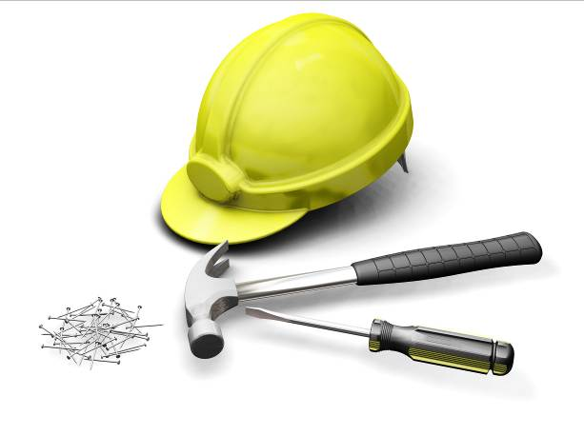

This form documents that the training specified above was presented to the listed participants. By signing below, each participant acknowledges receiving this training.

Organization: Date:

Trainer: Trainer’s Signature:

Class Participants:

Name: Signature:

Name: Signature:

Name: Signature:

Name: Signature:

Name: Signature:

Name: Signature:

Name: Signature:

Name: Signature:

Name: Signature:

Name: Signature:

Name: Signature:

Name: Signature:

Name: Signature:

Name: Signature:

Name: Signature:

Name: Signature:

