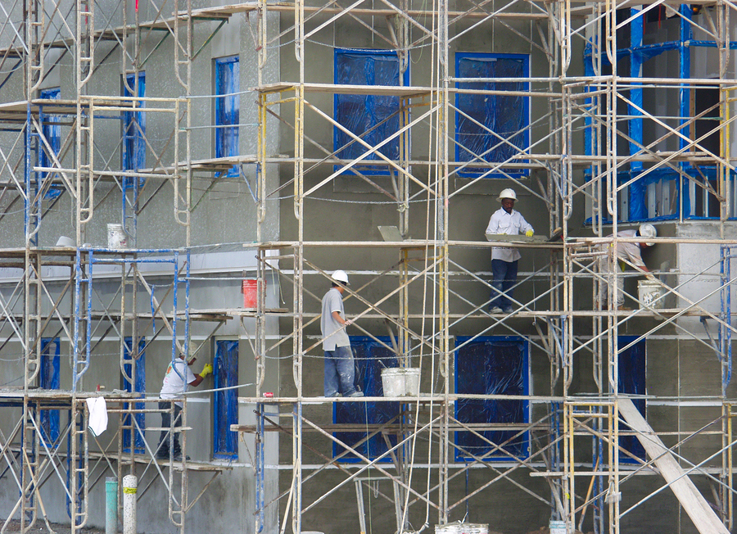

**Scaffold Safety**

**Basics:**

* Are the legs stable?
* Is the scaffolding system correctly assembled, without using defective components?
* Are there any missing pieces?
* Is an adequate guardrail system arranged?
* Is the scaffold completely planked?
* Is the scaffold a proper distance from the building?
* Can the scaffold be accessed safely?
* Is the scaffold inspected on a regular basis?
* Is the scaffold maintained in a useable condition?