Who needs respiratory protection? Everyone should be familiar with the basic issues regarding respiratory protection. However, there are many more issues that need to be addressed as part of a comprehensive Respiratory Protection Program (RPP). If you are responsible for managing or administering your company’s RPP the following are some questions you will need to be able to answer:
- Do you require respirators in your workplace?
- Who needs a respirator to keep safe at work?
- Are your employees trained on how to use, care, and maintain respirators?
- Have employees been cleared to wear respirators by a medical professional?
- Are there different types of respirators?
- Which type is right for your valuable staff?

What is a respirator? A respirator is a piece of personal protective equipment that requires special attention when being used. It can be used to clean the air of contaminants from your breathing zone or supply clean air to a worker while inside the work area.
Respirator programs: If you are using or requiring someone in your organization to wear a respirator you need to have specific written programs in place that include:
- Hazard assessments, e.g., ventilation measurements, air exposure monitoring, etc.
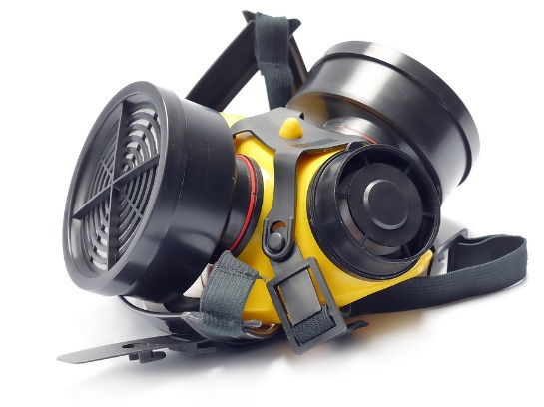
- Respirator selection, e.g., air purifying or air supplying
- Employee training and standard procedures
- Medical evaluations from licensed health care providers
- Fit testing, using quantitative or qualitative measures
- Program evaluation
- Record-keeping

What are the types of airborne hazards? Different respirators and or filtering cartridges may be required to protect against different airborne hazards. Some potential hazards are:
- Gases and vapors, e.g., xylene, isopropyl alcohol
- Mists and fogs, e.g., aerosol paints
- Fumes, e.g., welding, brazing, lead, hexavalent chromium
- Particulates, e.g., asbestos, silica, hexavalent chromium
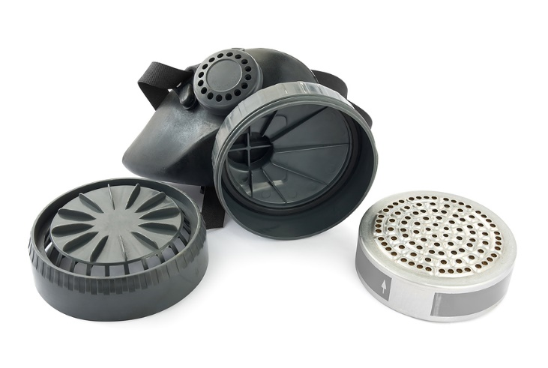
- Oxygen deficiency
Respirator selection options:
- Air purifying respirators

- Filtering face piece particulate respirators/cartridges
- Chemical cartridge respirators
- Powered air purifying respirators
- Canister respirators
- Air supplying respirators:

- Supplied air systems
- Self-contained breathing apparatus
Employer requirements: Additional information and action is required by the employer in accordance with the state and federal occupational safety and health regulations covering respiratory protection. This includes but is not limited to:
- Establishing a written respirator program
- Medical considerations
- Respirator fit testing
- Negative and positive pressure user fit checks
- Comprehensive user training, e.g., procedures for the use, care, maintenance, and storage of the respirator.

What’s on your face can save your lungs and life!

This form documents that the training specified above was presented to the listed participants. By signing below, each participant acknowledges receiving this training.

Organization: Date:

Trainer: Trainer’s Signature:

Class Participants:

Name: Signature:

Name: Signature:

Name: Signature:

Name: Signature:

Name: Signature:

Name: Signature:

Name: Signature:

Name: Signature:

Name: Signature:

Name: Signature:

Name: Signature:

Name: Signature:

Name: Signature:

Name: Signature:

Name: Signature:

Name: Signature:

