A solvent is a compound that dissolves another material, resulting in a solution. The most common solvent in everyday life is water. In fact, it is referred to as the “universal solvent.” In most workplaces, however, the most common solvents are organic materials such as paint thinners, degreasers, alcohols and petroleum distillates. These solvents can present significant danger, as they evaporate into the air in confined or poorly ventilated areas.
Characteristics of solvents:
- They usually have a low boiling point.
- Many are flammable and evaporate easily.
- Usually they are clear, liquid and often have a characteristic odor.

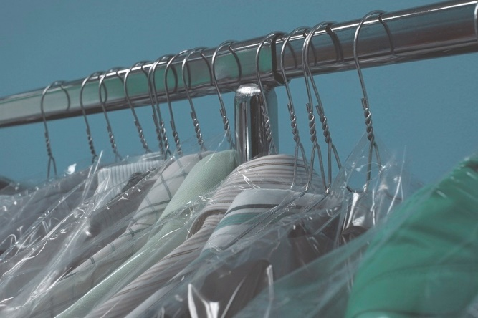
Common uses for organic solvents:
- Degreasing operations
- Industrial cleaners
- Dry cleaning operations
- Paint thinners
- Nail polish removers
- Dissolving glue
- Spot removers
- Detergents and cosmetics
Health hazards:
- Solvent vapor can irritate breathing passages, e.g., noses, throats or lungs.
- Some solvents may displace breathing air.
- Long-term exposure may be harmful to the liver, kidney, lungs, eyes, and nervous system.
- Prolonged skin contact with solvents can cause drying and cracking of skin and irritation to the eyes.
Control measures:
- Training: Only people who are trained and authorized are allowed to handle these materials.
- Before using a solvent, review the following: the current safety data sheet (SDS), including the solvent’s physical and chemical hazards; the Hazard Assessment; the required controls; the proper personal protective equipment (PPE); the engineering controls and the administrative controls.
- Follow the specified proper eye, skin and respiratory protection.
- Know all spill and emergency handling requirements.
- Maintain proper controls: These will provide the necessary protection against potential injuries and long-term health effects.
- Ensure that fixed or portable local exhaust ventilation is in operation in the vicinity where solvents are being used.
- If local exhaust ventilation is not adequate and the work would result in breathing solvent vapors, specified respiratory equipment must be worn in accordance with the written respiratory protection program.
- Follow all confined space program requirements. Ensure that the space is monitored before and during activities by a trained and qualified person.
- Control ignition sources: If the material is flammable or combustible, ensure that all ignition sources are controlled. Do not use solvents on hot surfaces.
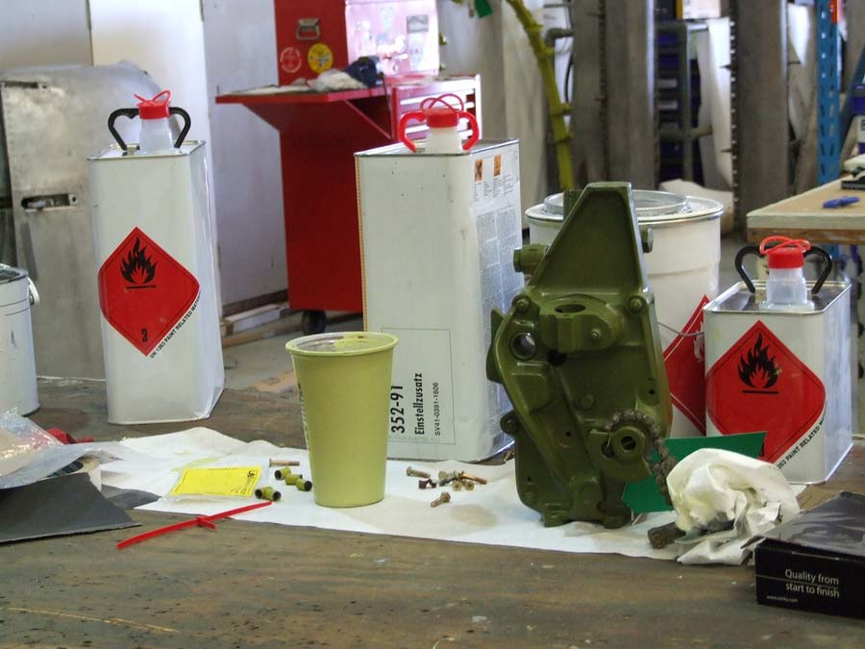
- Use and store solvents in areas free from sources of ignition, sparks, open flames and oxidizers such as calcium hypochlorite, sodium nitrate and peroxides.
- Store solvents in designated flammable liquid storage rooms, cabinets or lockers.
- Make sure that containers are tightly closed when not in use.
- Do not store aerosol solvents in areas with temperatures above 120˚ F.
- Use solvents carefully:
  - Use a particular solvent only for its intended purpose; do not use any solvents for unauthorized applications.
  - Keep solvent containers closed when not in use to avoid breathing the solvent vapors.
  - If using solvents from aerosol cans make sure that the nozzle is pointed away from the face.

Handle solvents with care and be aware of hazardous vapors, especially when working in confined spaces.

This form documents that the training specified above was presented to the listed participants. By signing below, each participant acknowledges receiving this training.

Organization: Date:

Trainer: Trainer’s Signature:

Class Participants:

Name: Signature:

Name: Signature:

Name: Signature:

Name: Signature:

Name: Signature:

Name: Signature:

Name: Signature:

Name: Signature:

Name: Signature:

Name: Signature:

Name: Signature:

Name: Signature:

Name: Signature:

Name: Signature:

Name: Signature:

Name: Signature:

