Hazards of voltage testing: Anyone performing electrical measurements must understand the safety hazards associated with this task and be certain that their tools meet code requirements. Persons testing voltage on energized equipment or for verification on locked out equipment can be injured if test instruments are not appropriately applied or the wrong instrument is used for the job.

Make sure your instrument is appropriately rated for the equipment being tested:
- Qualified persons need to be trained to select an appropriate voltage detector and must be able to demonstrate how to use a device to verify the absence of voltage, including interpreting indications provided by the device.
- The training needs to include information that enables the employee to understand all limitations of each specific voltage detector that may be used.
- The International Electro-technical Commission (IEC) Standard 61010 describes performance specifications for test equipment.
- The higher the category, the higher the power available in that environment, and the higher the test tool’s ability needs to be to withstand transient energy.
- Four Measurement Categories (“CAT” Ratings) are assigned to test instruments which correspond to use applications.
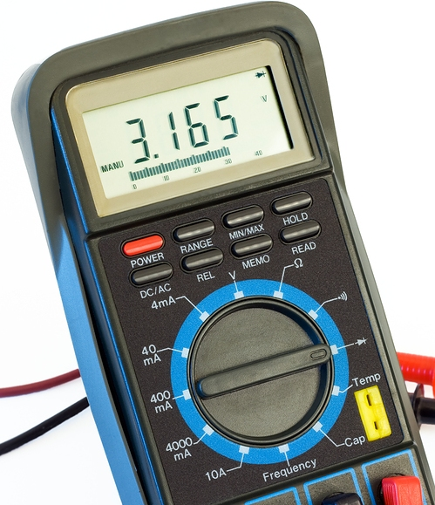
- General Rules for Test Equipment
  - Closer you get to a power source, the higher the CAT number requirement
  - The greater the short circuit current available, the greater the CAT number required
  - The greater the source impedance, the lower the CAT number (a 2 Ω source has a higher CAT number than a 30 Ω source)
  - Set a multimeter to the highest CAT number for which the device is to be used.

Category | Types of Measurements | Examples
I | - Voltage levels are low  - Protected electronic equipment such as a photocopier or computer  - Equipment connected to circuits in which measures are taken to limit over-voltages to appropriately low level
II | - Single phase receptacle connected loads  - Appliances, portable tools, and other household or similar loads  - Outlet/branch circuits | 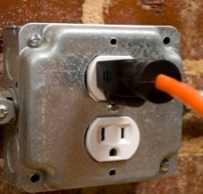
III | - 3-Phase Distribution  - Single-Phase commercial lighting  - Fixed location equipment such as distribution panels and motors
IV | - 3-Phase at utility connection  - Any outdoor location  - Origin of installation where low voltage connection is made to utility power

Other safety requirements when using test instruments:
- Follow a sound Lockout Procedure and ensure staff are utilizing proper Personal Protective Equipment (PPE) in accordance with a Hazard Assessment; including voltage rated gloves and arc flash equipment
- Make sure you apply test leads properly (black to positive, red to negative)
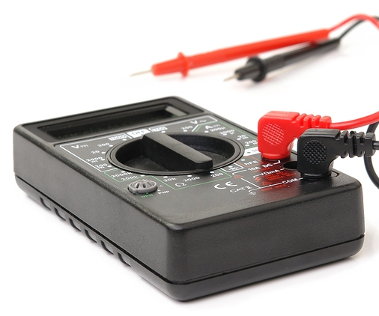
- Inspect all test meters to ensure they are in good condition before use
- Know your test equipment. Know the controls for measurement including settings to use for measuring voltage, amperage, and resistance.

This form documents that the training specified above was presented to the listed participants. By signing below, each participant acknowledges receiving this training.

Organization: Date:

Trainer: Trainer’s Signature:

Class Participants:

Name: Signature:

Name: Signature:

Name: Signature:

Name: Signature:

Name: Signature:

Name: Signature:

Name: Signature:

Name: Signature:

Name: Signature:

Name: Signature:

Name: Signature:

Name: Signature:

Name: Signature:

Name: Signature:

Name: Signature:

Name: Signature:

