Objective: To promote a safe working atmosphere, electrical outlets should be inspected periodically and before each use.

Electricity is an essential source of power in today’s productive workforce. It is used to power our computers, tools, machinery, lighting, etc. The workplace is going to have many electrical sources that could be hazardous. This would include transformers, electrical breakers, power cords, conduits, and one source that nearly every employee will encounter at some point in their life, the electrical outlet.
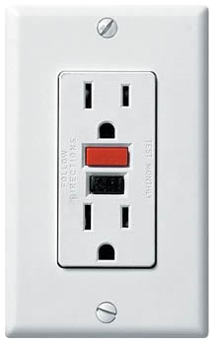
The typical outlet is typically a 120-volt power source socket which accepts power cords. These will be found in several spots along the wall of a facility or there may electrical outlet boxes which have been dropped down from the ceiling via a power cord or conduit. Outlets are commonly used however they can also be dangerous receptacles because they are sources of electricity.
To promote a safe working atmosphere, electrical outlets should be inspected for the following on a periodic basis.
Items to be on the lookout for would include:
- Outlets with no ground port
  - Older facilities may have outlets with only two ports which means the ground is missing
- Exposed wiring
- Missing or damaged cover plates
- Cracked outlets
- Missing outlets
- Burn marks around the outlet receptacles
- Plug prongs broken and engaged in the outlet receptacle
- Ground pins engaged in the receptacle
- Outlet overloading
- Do not paint over an outlet or intentionally paint an outlet
- Outlets found in areas where children are normally present should have child proof protection
- If the outlet is outdoors or in a water spray area, then the following must be in place
  - Outlet is on a Ground Fault Circuit Interrupter (GFCI)
  - Outlet has a water proof cover plate which covers the receptacles

When you are planning to use an outlet, make sure to follow safe procedures when plugging or unplugging from the receptacle:
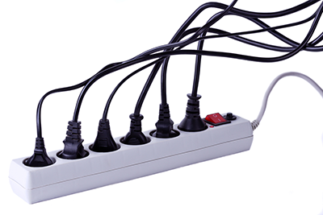
- Check the plug prongs for any damage or bent metal fittings
- Make sure that the voltage and amperage is rated for the receptacle
- Be sure that the plug fits firmly, and check for any signs of heating caused by faulty connections
- Do not cut a ground pin from the plug head to make the outlet fit into the receptacle
- Inspect your power cord before plugging in
- When using an outlet multiplier or “power strip” that multiplier needs to have a surge protection or GFCI

When removing the cord or unplugging, remember the following:
- Do not “yank” on the cord to remove the plug from the receptacle
  - This can cause an outlet can break the cord's insulation and wires, pull loose wire connections, or bend plug prongs
- Walk to the receptacle and unplug the power cord before rolling up the cord
  - The cord needs to be deenergized. If an employee attempts to roll up an energized cord, then the employee could be shocked if the cord is damaged

This form documents that the training specified above was presented to the listed participants. By signing below, each participant acknowledges receiving this training.

Organization: Date: ________________________

Trainer: Trainer’s Signature: _____

Class Participants:

Name: ____ _______ Signature: ___________
Name: ____ _______ Signature: ___________
Name: ____ _______ Signature: ___________
Name: ____ _______ Signature: ___________
Name: ____ _______ Signature: ___________
Name: ____ _______ Signature: ___________
Name: ____ _______ Signature: ___________
Name: ____ _______ Signature: ___________
Name: ____ _______ Signature: ___________
Name: ____ _______ Signature: ___________
Name: ____ _______ Signature: ___________
Name: ____ _______ Signature: ___________
Name: ____ _______ Signature: ___________
Name: ____ _______ Signature: ___________
Name: ____ _______ Signature: ___________
Name: ____ _______ Signature: ___________

