**Extension cords are everywhere:**

Extension cords can be found in nearly all vocational settings due to the widespread use of electronic equipment and electrically powered tools. They are more susceptible to damage than fixed wiring because they are exposed, flexible, and unsecured. The normal wear and tear on extension cords can loosen or expose internal wires and create hazardous conditions. Extension cords are intended for temporary use only and are not intended to replace fixed wiring. Three prong wire cords that have not been extensively used and that are not modified represent less of a risk of electric shock.

**Cord damage:**

* Extension cords can be damaged by doors, window edges, staples, fasteners, abrasion from adjacent materials, and simple aging.
* If the electrical conductors become exposed there is a high risk of injury due to electric shock and fire.

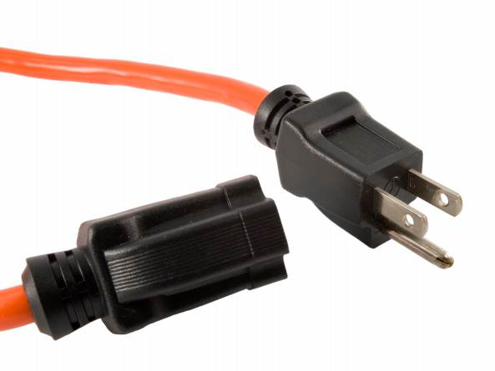**Strain relief:**

* The flexible cord material must connect to devices in ways that prevent tension at joints and terminal screws.
* For flexibility, the cord material is made of finely stranded wires.
* Stressing a cord can cause the strands of one conductor to loosen from a terminal screw and touch other conductors.
* Intact “strain reliefs” help to keep cord termination points safe.

**Durability:**

* Electrical codes [e.g., Article 400 of the National Electrical Code (NEC)], provide construction requirements based on location, use, amperage requirements, and other factors.
* These construction requirements are derived from the National Electrical Code and are required to be marked on the cord at approximately every foot.
* Examples of these code types are *S, ST, SO, STO, SJ, SJO, SJT,* and *SJTO*.
* These ratings establish cable voltage ratings, indoor or outdoor use conditions, and cable jacket construction requirements described in Article 400 of the NEC.

**Grounding:**

* Extension cords must be a 3-prong type, which will provide grounding of the equipment being used.
* Never use an extension cord with a missing or damaged ground prong.

**Wet conditions:**

* When a cord connection is wet, electrical current can leak from a *hot* wire to the *grounding* conductor and to whoever handles that connection.
  + Such leakage can occur, not just on the face of the connector, but at any wet portion.
* Limit the exposure of cords, connectors, and tools to excessive moisture by using water-tight or sealable connections.
* The use of ground-fault circuit interrupters (GFCIs) greatly reduces the danger inherent in exposure to water and is advised for all applications.

**Avoid hazards:**

* Use factory-assembled cords that are properly rated for the application.
* Use only extension cords that are a 3-prong type.
* Use only extension cords that are marked with a designation of heavy or extra-heavy usage.
* Use only cords, connection devices, and fittings that are equipped with strain reliefs.
* Remove cords from receptacles by pulling on the plugs and not on the cords.
* Conduct regular cord inspections. Any damaged, unmarked, or modified cords should be cut up and thrown away.
* Use GFCIs at all times.
* Only use extension cords for temporary applications. Long term electrical use requires fixed wiring.

**Inspection:**

* Inspect and test all cords before use.
* Do not use a damaged cord.
* Implement a test and implement a ground assurance program for everyone’s safety!

This form documents that the training specified above was presented to the listed participants. By signing below, each participant acknowledges receiving this training.

Organization: Date:

Trainer: Trainer’s Signature:

**Class Participants:**

Name: Signature:

Name: Signature:

Name: Signature:

Name: Signature:

Name: Signature:

Name: Signature:

Name: Signature:

Name: Signature:

Name: Signature:

Name: Signature:

Name: Signature:

Name: Signature:

Name: Signature:

Name: Signature:

Name: Signature:

Name: Signature: